hw05.syswrite 406410114郭晏誠

1. 請將sys_write追蹤完畢，說明從剛開始到「於terminal中印出字串」為止的函數。

(1)b sys_write後停在635行 在638行設置中斷點

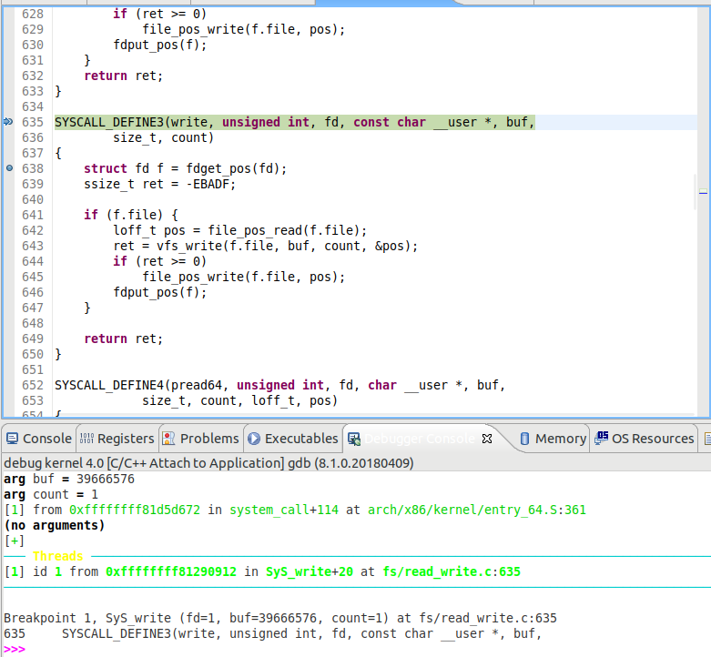

(2)按c跳到638用s 開始追蹤

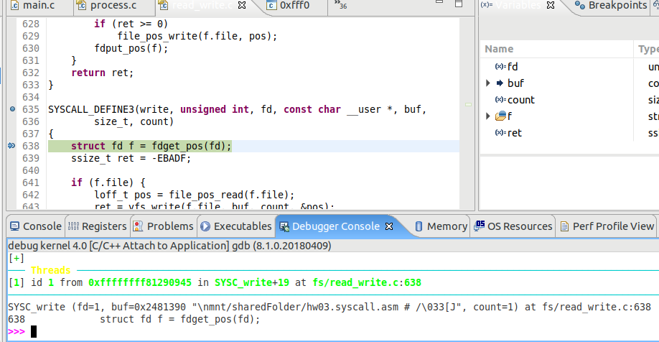

(3)追蹤過程見下方表格，詳細截圖過程請見附錄

|  |  |  |  |
| --- | --- | --- | --- |
| Index | File and column | Function code | Mark |
| 1 | fs/read_write.c:638 | **struct** fd f = fdget_pos(fd); |  |
| 2 | fs/read_write.c:270 | **return** __to_fd(__fdget_pos(fd)); |  |
| 3 | fs/file.c:708 | **unsigned** **long** v = __fdget(fd); |  |
| 4 | fs/file.c:697 | **return** __fget_light(fd, FMODE_PATH); |  |
| 5 | fs/file.c:680 | **struct** files_struct *files = current->files; |  |
| 6 | ./arm/x86/include/asm/current.h:14 | **return** this_cpu_read_stable(current_task); |  |
| 7 | fs/file.c:680 | **struct** files_struct *files = current->files; |  |
| 8 | fs/file.c:683 | **if** (atomic_read(&files->count) == 1) { |  |
| 9 | ./arm/x86/include/asm/atomic.h:27 | **return** ACCESS_ONCE((v)->counter); |  |
| 10 | fs/file.c:684 | file = __fcheck_files(files, fd); |  |
| 11 | include/linux/fdtable:77 | **struct** fdtable *fdt = rcu_dereference_raw(files->fdt); |  |
| 12 | include/linux/fdtable:79 | **if** (fd < fdt->max_fds) |  |
| 13 | include/linux/fdtable:80 | **return** rcu_dereference_raw(fdt->fd[fd]); |  |
| 14 | fs/file.c:685 | **if** (!file || unlikely(file->f_mode & mask)) |  |
| 15 | fs/file.c:687 | **return** (**unsigned** **long**)file; |  |
| 16 | fs/file.c:709 | **struct** file *file = (**struct** file *)(v & ~3); |  |
| 17 | fs/file.c:711 | **if** (file && (file->f_mode & FMODE_ATOMIC_POS)) { |  |
| 18 | fs/file.c:717 | **return** v; |  |
| 19 | include/linux/file.h:50 | **return** (**struct** fd){(**struct** file *)(v & ~3),v & 3}; |  |
| 20 | fs/read_write.c:639 | ssize_t ret = -EBADF; |  |
| 21 | fs/read_write.c:641 | **if** (f.file) { |  |
| 22 | fs/read_write.c:642 | loff_t pos = file_pos_read(f.file); |  |
| 23 | fs/read_write.c:612 | **return** file->f_pos; |  |
| 24 | fs/read_write.c:643 | ret = vfs_write(f.file, buf, count, &pos); |  |
| 25 | fs/read_write.c:580 | **if** (!(file->f_mode & FMODE_WRITE)) |  |
| 26 | fs/read_write.c:582 | **if** (!(file->f_mode & FMODE_CAN_WRITE)) |  |
| 27 | fs/read_write.c:584 | **if** (unlikely(!access_ok(VERIFY_READ, buf, count))) |  |
| 28 | ./arm/x86/include/asm/thread_info.h:162 | ti = (**void** *)(this_cpu_read_stable(kernel_stack) + |  |
| 29 | ./arm/x86/include/asm/thread_info.h:163 | KERNEL_STACK_OFFSET - THREAD_SIZE); |  |
| 30 | ./arm/x86/include/asm/thread_info.h:164 | return ti; |  |
| 31 | ./arm/x86/include/asm/uaccess.h:57 | addr += size; |  |
| 32 | ./arm/x86/include/asm/uaccess.h:58 | **if** (addr < size) |  |
| 33 | ./arm/x86/include/asm/uaccess.h:60 | **return** addr > limit; |  |
| 34 | fs/read_write.c:587 | ret = rw_verify_area(WRITE, file, pos, count); |  |
| 35 | fs/read_write.c:391 | **int** retval = -EINVAL; |  |
| 36 | fs/read_write.c:393 | inode = file_inode(file); |  |
| 37 | include/linux/fs.h:1963 | **return** f->f_inode; |  |
| 38 | fs/read_write.c:394 | **if** (unlikely((ssize_t) count < 0)) |  |
| 39 | fs/read_write.c:396 | pos = *ppos; |  |
| 40 | fs/read_write.c:397 | **if** (unlikely(pos < 0)) { |  |
| 41 | fs/read_write.c:402 | } **else** **if** (unlikely((loff_t) (pos + count) < 0)) { |  |
| 42 | fs/read_write.c:407 | **if** (unlikely(inode->i_flctx && mandatory_lock(inode))) { |  |
| 43 | fs/read_write.c:414 | retval = security_file_permission(file, |  |
| 44 | security/security.c:713 | ret = security_ops->file_permission(file, mask); |  |
| 45 | security/selinux/hooks.c:3215 | **struct** inode *inode = file_inode(file); |  |
| 46 | include/linux/fs.h:1963 | **return** f->f_inode; |  |
| 47 | security/selinux/hooks.c:3216 | **struct** file_security_struct *fsec = file->f_security; |  |
| 48 | security/selinux/hooks.c:3217 | **struct** inode_security_struct *isec = inode->i_security; |  |
| 49 | security/selinux/hooks.c:218 | **const** **struct** task_security_struct *tsec = current_security(); |  |
| 50 | ./arm/x86/include/asm/current.h:14 | **return** this_cpu_read_stable(current_task); |  |
| 51 | security/selinux/hooks.c:218 | **const** **struct** task_security_struct *tsec = current_security(); |  |
| 52 | security/selinux/hooks.c:220 | **return** tsec->sid; |  |
| 53 | security/selinux/hooks.c:3220 | **if** (!mask) |  |
| 54 | security/selinux/avc.c:774 | **return** avc_cache.latest_notif; |  |
| 55 | security/selinux/hooks.c:3227 | **return** 0; |  |
| 56 | security/security.c:714 | **if** (ret) |  |
| 57 | fs/read_write.c:635 | SYSCALL_DEFINE3(write, **unsigned** **int**, fd, **const** **char** __user *, buf, |  |
| 1~57行會重複做2-3次不等，但是螢幕沒有印出第一行，猜測可能是有呼叫到sys_write但是是把一些東西寫道cache，並非螢幕上，例如：寫指令到history | | | |
| 58 | include/linux/fsnotify.h:40 | **struct** path *path = &file->f_path; |  |
| 59 | include/linux/fs.h:1963 | **return** f->f_inode; |  |
| 60 | include/linux/fsnotify.h:42 | __u32 fsnotify_mask = 0; |  |
| 61 | include/linux/fsnotify.h:45 | **if** (file->f_mode & FMODE_NONOTIFY) |  |
| 62 | fs/read_write.c:416 | **if** (retval) |  |
| 63 | fs/read_write.c:588 | **if** (ret >= 0) { |  |
| 64 | fs/read_write.c:589 | count = ret; |  |
| 65 | fs/read_write.c:590 | file_start_write(file); |  |
| 66 | include/linux/fs.h:2381 | **if** (!S_ISREG(file_inode(file)->i_mode)) |  |
| 67 | include/linux/fs.h:1963 | **return** f->f_inode; |  |
| 68 | include/linux/fs.h:2383 | __sb_start_write(file_inode(file)->i_sb, *SB_FREEZE_WRITE*, true); |  |
| 69 | include/linux/fs.h:1963 | **return** f->f_inode; |  |
| 70 | include/linux/super.c:1194 | **if** (unlikely(sb->s_writers.frozen >= level)) { |  |
| 71 | include/linux/super.c:1204 | percpu_counter_inc(&sb->s_writers.counter[level-1]); |  |
| 72 | include/linux/percpu_counter.h:116 | percpu_counter_add(fbc, 1); |  |
| 73 | include/linux/percpu_counter.h:48 | __percpu_counter_add(fbc, amount, percpu_counter_batch); |  |
| 74 | include/linux/percpu_counter.:80 | count = __this_cpu_read(*fbc->counters) + amount; |  |
| 75 | include/linux/percpu-defs.:300 | **static** **inline** **void** **__this_cpu_preempt_check**(**const** **char** *op) { } |  |
| 76 | include/linux/percpu_counter.:81 | **if** (count >= batch || count <= -batch) { |  |
| 77 | include/linux/percpu_counter.:88 | this_cpu_add(*fbc->counters, amount); |  |
| 78 | include/linux/super.c:1204 | smp_mb(); |  |
| 79 | include/linux/super.c:1210 | **if** (unlikely(sb->s_writers.frozen >= level)) { |  |
| 80 | include/linux/super.c:1214 | **return** 1; |  |
| 81 | fs/read_write.c:591 | **if** (file->f_op->write) |  |
| 82 | fs/read_write.c:592 | ret = file->f_op->write(file, buf, count, pos); |  |
| 83 | fs/read_write.c:526 | **struct** iovec iov = { .iov_base = (**void** __user *)buf, .iov_len = len }; |  |
| 84 | fs/read_write.c:531 | init_sync_kiocb(&kiocb, filp); |  |
| 85 | ./arm/x86/include/asm/aio.h:67 | .ki_obj.tsk = current, |  |
| 86 | ./arm/x86/include/asm/current.h:14 | **return** this_cpu_read_stable(current_task); |  |
| 87 | ./arm/x86/include/asm/aio.h:67 | .ki_obj.tsk = current, |  |
| 88 | ./arm/x86/include/asm/aio.h:64 | *kiocb = (**struct** kiocb) { |  |
| 89 | fs/read_write.c:532 | kiocb.ki_pos = *ppos; |  |
| 90 | fs/read_write.c:533 | kiocb.ki_nbytes = len; |  |
| 91 | fs/read_write.c:534 | iov_iter_init(&iter, WRITE, &iov, 1, len); |  |
| 92 | Lib/iov_iter.c :325 | **if** (segment_eq(get_fs(), KERNEL_DS)) { |  |
| 93 | ./arm/x86/include/asm/thread_info.h:162 | ti = (**void** *)(this_cpu_read_stable(kernel_stack) + |  |
| 94 | Lib/iov_iter.c :330 | i->type = direction; |  |
| 95 | fs/read_write.c:534 | ret = filp->f_op->write_iter(&kiocb, &iter); |  |
| 96 | mm/filemap.c:2656 | **struct** file *file = iocb->ki_filp; |  |
| 97 | Kernel/locking/mutex:97 | might_sleep(); |  |
| 98 | Kernel/sched/core.c:4206 | **if** (should_resched()) { |  |
| 99 | ./arm/x86/include/asm/preempt.h:95 | **return** unlikely(!raw_cpu_read_4(__preempt_count)); |  |
| 100 | Kernel/sched/core.c:4206 | **if** (should_resched()) { |  |
| 101 | Kernel/sched/core.c:2845 | __preempt_count_add(PREEMPT_ACTIVE); |  |
| 102 | ./arm/x86/include/asm/preempt.h:72 | raw_cpu_add_4(__preempt_count, val); |  |
| 103 | Kernel/sched/core.c:2845 | __schedule(); |  |
| 104 | Kernel/sched/core.c:2721 | cpu = smp_processor_id(); |  |
| 105 | Kernel/rcu/tree.c:285 | trace_rcu_utilization(TPS("Start context switch")); |  |
| … 中間開始進入要搶lock階段會經過spinlock, ticklock, fair.c等function ，並且會常常進出tree.c做資料結構處理，這段非常的冗長，詳情請見附錄(p37-p73) | | | |
| 106 | fs/read_write.c:536 | ret = filp->f_op->write_iter(&kiocb, &iter); |  |
| 107 | fs/read_write.c:537 | **if** (-EIOCBQUEUED == ret) |  |
| 108 | fs/read_write.c:537 | *ppos = kiocb.ki_pos; |  |
| 109 | fs/read_write.c:540 | return ret; |  |
| 110 | fs/read_write.c:597 | if (ret > 0) { |  |
| 111 | fs/read_write.c:601 | inc_syscw(current); |  |
| 112 | fs/read_write.c:635 | SYSCALL_DEFINE3(write, **unsigned** **int**, fd, **const** **char** __user *, buf, |  |

(4)印出第一行：

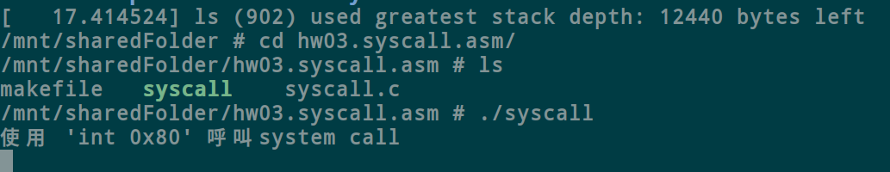

附錄：



